Name:____________________________________________ Date:________________ Period: _______

Quiz 1 – Circular (5 Points)

An engineer is trying to determine the speed at which she can swing a 500 kg wrecking ball without breaking her cable. She knows that the cable is rated to withstand 7500 N of tension.
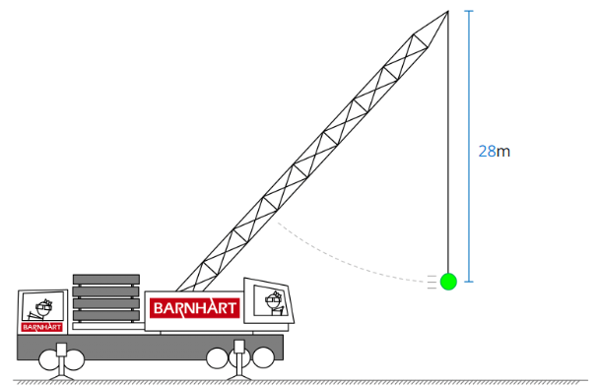
FBD

a) Draw the FBD of the ball…label the forces (ignore air resistance)
b) Determine the following when the cable is at the breaking tension (show steps and include UNITS):
Radius of curved path: _______________
Mass of the ball: _____________
Weight of the ball: _______________
Tension in the cable: ______________
Net Centripetal Force on the ball: ______________

Centripetal Acceleration of Ball: _____________
Speed of the Ball: _____________

